|  |  |
| --- | --- |
| Name (Sap Id): | Kalpita Shankhdhar (60004210164)  Akshata Sunil Dharmadhikari (60004220125)  Prerna Sunil Jadhav (60004220127) |
| Class: | T. Y. B. Tech (Computer Engineering) |
| Course: | Software Engineering Laboratory |
| Course Code: | DJ19CEL601 |
| Experiment No.: | 03 |

**USE CASE DIAGRAM:**

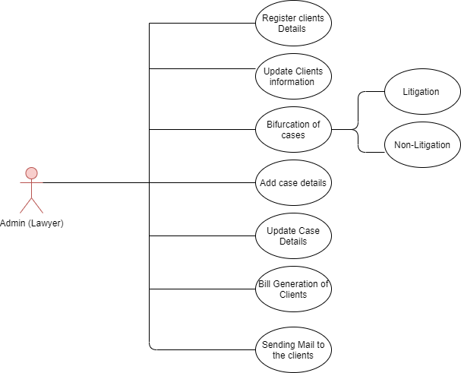**For Lawyer/Admin:**

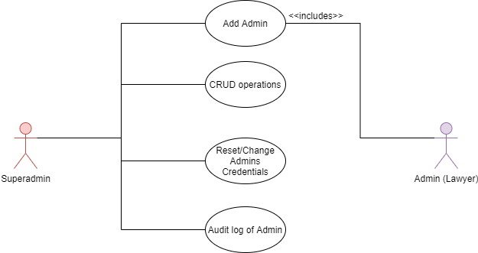**For SuperAdmin:**

**CLASS DIAGRAM:**

